System Specification for

Adventures of an Adventurer

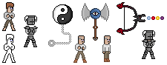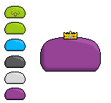

|  |  |
| --- | --- |
| Project Name | The Adventures of an Adventurer |
| Project Manager | Sascha Bertleff |
| Document Owner | Group Ferstel, Schmidt, Bertleff |
| Created on | 22.12.15 |
| Last modified | 22 December 2015, 08:14:00 |
| State | X in Work  vorgelegt  Released |
| Dokumentablage | Group Ferstl, Schmidt, Bertleff System Specifications |

**Document History**

|  |  |  |  |  |  |
| --- | --- | --- | --- | --- | --- |
| Nr. | Date | Version | Chapter | Modification | Author |
| 1 | 22.12.15 | 0.1 | 1 | Creation of the Document | Sascha Bertleff |
| 2 | 19.01.16 | 0.2 | 1-3 | Creation and modification of chapter 1 to 3 | Sascha Bertleff |
| 3 | 26.01.16 | 0.3 | 1,2,3,4 | Extending of chapter 2,3 and 4 | Sascha,  Cedric,  Oguz |
| 4 | 02.02.16 | 0.4 | 1,2,3,4 | Finished Chapter 1 to 4 | Sascha,  Cedric,  Oguz |
| 5 | 18.10.2016 | 0.4.1 | 2 | Created GUI Section of Chapter 2 | Cedric, Sascha |
| 6 | 21.10.16 | 0.4.2 | 2 | Edited GUI Section of Chapter 2 | Sascha |
| 7 | 25.10.16 | 0.4.3 | 2 | Edited GUI and OP Section of Chapter 2 | Sascha, Cedric |
| 8 | 28.10.16 | 0.5 | 6 | Created and edited Acceptance Criteria | Cedric,  Sascha |
| 9 | 29.11.16 | 0.5.1 | 6 | Created and edited Acceptance Criteria | Sascha |
| 10 | 06.12.16 | 0.5.1 | 6 | Edited Acceptance Criteria | Cedric, Sascha |
| 11 | 13.01.17 | 0.5.2 | 6 | Edited Acceptance Criteria | Sascha, Steffi |
| 12 | 17.01.17 | 0.6 | 2,6 | Added some Use Case Descriptions | Sascha |
| 13 | 22.01.17 | 0.6.1 | 2 | Added new Use Case Descriptions | Sascha |

Inhaltsverzeichnis

1. Initial Situation and Goal 2

1.1 Initial Situation 2

1.1.1 Application Domain 2

1.1.2 Glossary 2

1.2 Goal Definition 2

2. Functional Requirements 2

2.1 Use Case Diagrams 2

2.2 Explanation of the Use Cases 2

• Use Case: Game ID: 1 2

• Use Case: Fighting ID: 1.1 2

• Use Case: Fight Enemies ID: 1.1.1 2

• Use Case: Hit ID: 1.1.2 2

• Use Case: Dodge ID: 1.1.3 2

• Use Case: Shot with Bow and Arrow ID: 1.1.4 2

• Use Case: Dialogue ID: 1.2 2

• Use Case: Store Items ID: 1.2.1 2

• Use Case: Funny Dialogs ID: 1.2.2 2

• Use Case: Trade ID: 1.2.3 2

• Use Case: Get Quest ID: 1.2.4 2

• Use Case: Get Money/items ID: 1.2.3.1, 1.2.3.1.1, 1.3.1.1 2

• Use Case: Exploring ID: 1.3 2

• Use Case: Find new Places 2

• Use Case: Find Treasures ID: 1.3.1 2

2.2.2 GUI of the Game 2

2.3 Open Points 2

3. Non-functional Requirements 2

4. Quantity Structure (Schätzung Größe) 2

5. System Architecture and Interfaces 2

6. Acceptance Criteria 2

# 1. Initial Situation and Goal

The main goal of our Project is to create a Game which people can enjoy and find funny. This happens with the humorous story or with many innuendos and game elements which are just so random, that they are amusing.

We want to keep the game simple, so that it can run on every Standard PC from nowadays.

The art style of the game is like an old SNES game. Many pixels

The compatibility with other Systems will not be a problem because the Unity-Engine runs on nearly every common operating system (For Example: Windows, Mac, and Linux). We also plan to release the Game for Wii U later on.

## 1.1 Initial Situation

Beside the clarification of the initial situation in the project proposal this game is made for the classic pixel art gamer, but honestly everyone can play it and should be have his/her fun with it. According to the game it will run on the most PC’s on Windows XP and above. After Windows the game would be playable at any Linux and MAC system. Our later goal would be to bring our game to the mobile market and develop it for Android and IOS and maybe also for Wii U. Further information will be published.

### 1.1.1 Application Domain

The game will be very simple and should not make any trouble with performance of the game or a high hardware usage. The main problem area could be the compatibility of the Unity version. Briefly said, our game should run on any PC’s which can support Unity 5.3 or above. Later in the development the game should run on any Android device with Android 2.3 and above and any IOS device with IOS 5 and above.

### 1.1.2 Glossary

* **SNES**: Super Nintendo Entertainment System; a gaming console made by Nintendo from 1990
* **Wii U**: a gaming console made by Nintendo from 2012
* **Quest**: a task given to the player by another person, mostly to receive a reward in exchange; a journey towards a goal
* **Item**: an object that in most cases has a certain usage
* **DLC:** Download Content; exclusive downloadable extra content for the game
* **Pixel Art:** pictures or graphics that are drawn using only a short amount of pixels, like for example 16x16
* **Steam:** an Internet-based digital distribution platform developed by Valve Corporation
* **Indie Games:** video games created by individuals or small teams generally without video game publisher financial support
* **Unity:** a multiple-platform game engine and development toolkit
* **RPG:** Role-Playing Game, a game genre
* **Cut Scene:** Non-playable Scene which reveals more about the Story or is just a funny sequence.
* **Open-World:** The term “open world” often describes, that the player is free to explore the world of the game.
* **NPC:** (Non-playable-Character) A person which exists to inform the player about something or which the player just can chat with.

## 1.2 Goal Definition

The main goal of the game is to entertain any kind of person and bring joy and fun among them. Although the main reason of a game is to have fun while playing we are trying to give the best experience of a 2D Action RPG game. The target group is simple everybody from children to older person. Mostly RGP players should have his/her fun, but everybody should have his/her fun either.

# 2. Functional Requirements

## 2.1 Use Case Diagrams

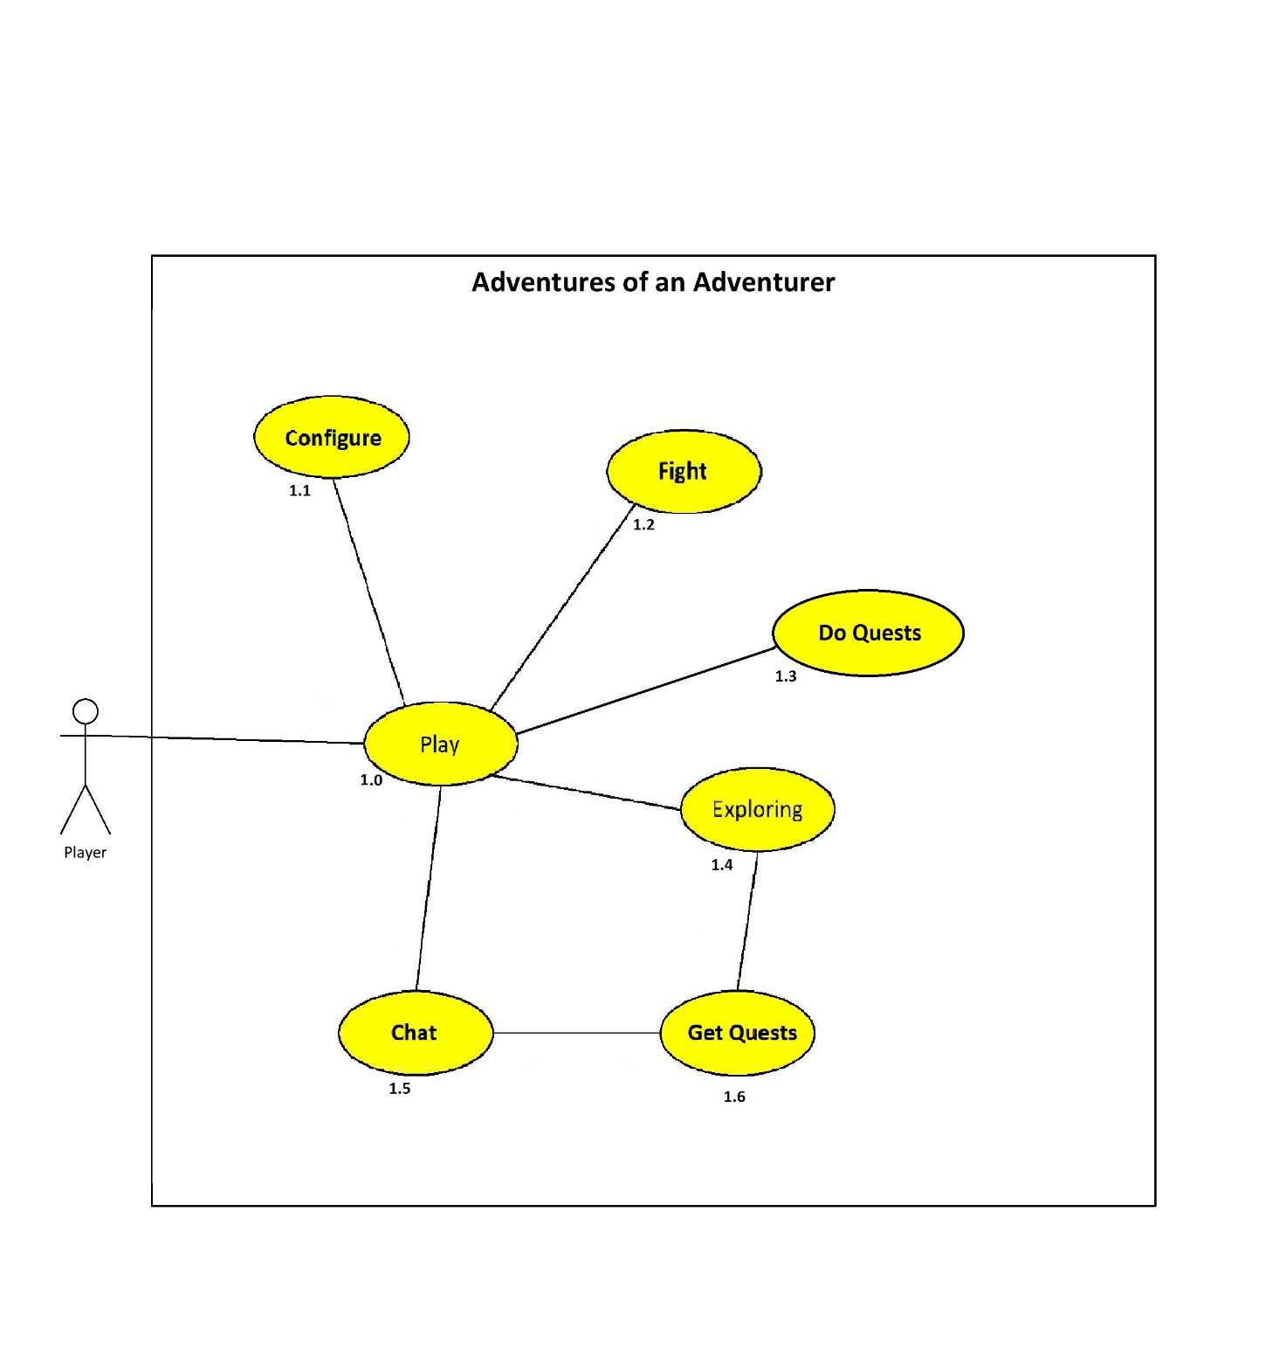

## 2.2 Explanation of the Use Cases

### Use Case: Play ID: 1.0

The basic Idea of the Game is that the player has fun while playing the Game

### Use Case: Configure ID: 1.1

In order to provide the best experience for the player while he plays the game, he can choose several different options. These options are: the screen resolution, the graphic details and change the volume to a level which is comfortable for the player.

### Use Case: Fight ID: 1.2

One of the Main Elements of the Game is the Fighting System. When one encounters Enemies the player has to fight and defeat them. The player can choose between a variety of weapons to achieve this task. These weapons both contain melee and range weapons, but also spells.

### Use Case: Do Quests ID: 1.3

In order to progress in the game one has to gain Experience Points to do so the player has several options, one of them is to do quests. Quests can be something simple like collecting herbs for an alchemist or something more complex like an investigation for a missing person. Quests are also divided in Main Quests and Side Quests. When de player does Main Quests he progresses in the story and can therefore finish the game. When completing a Side Quest the player can earn additional experience points and gold.

### Use Case: Exploring ID: 1.4

A Main aspect of our game is the open world environment. The player is free to explore the environment and discover new things along the way. These things can be for example, a new item or a cave which can be explored.

### Use Case: Chat ID: 1.5

The Use Case Chat describes that the player can talk to every NPC in the game. While talking to an NPC it can also happen, that the player can get a new Quest or just an important information. Of Corse not every person as to say something useful and so there are also many funny dialogues which just entertain the player.

### Use Case: Get Quests ID: 1.6

A player can acquire quests by talking to a NPC (e.g.: a mage which lost his apprentice and the player has the quest to find him) or by just roaming the world (e.g.: an old lady which has wrenched her leg hand shouts for help)

## 2.2.2 GUI of the Game

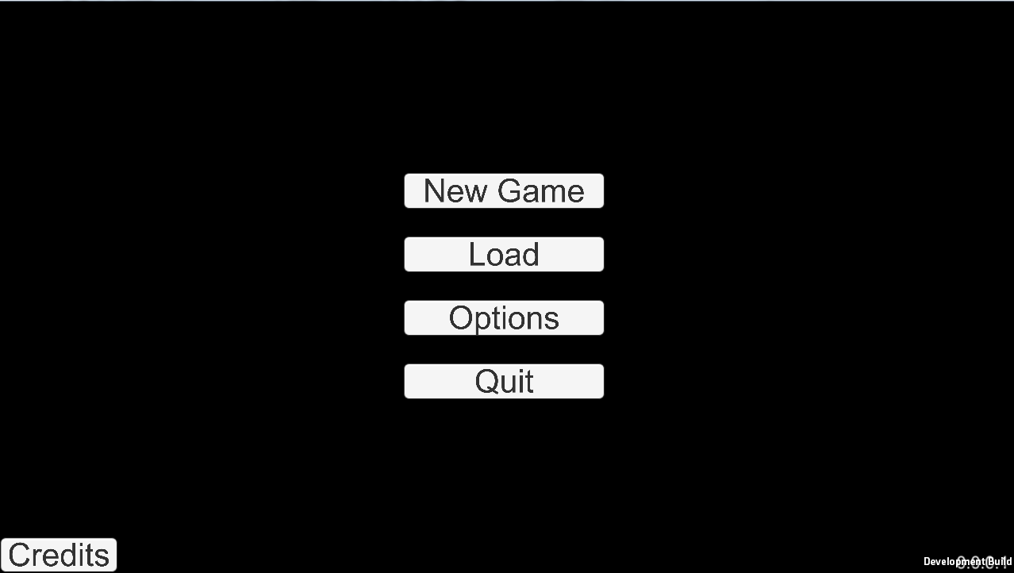(Note, that all GUI Elements are part of an early Development build and may be changed in later versions of the Game)

Quit: Closes the Game

Load: This button can be used, to load an existing Game. (There will be 3 Game Slots which one will be overwritten, if the player saves he game)

Options: Some options for the Game. E.g.: Audio, Language, Difficulty

New Game: With this button, the Player can start a new Game.

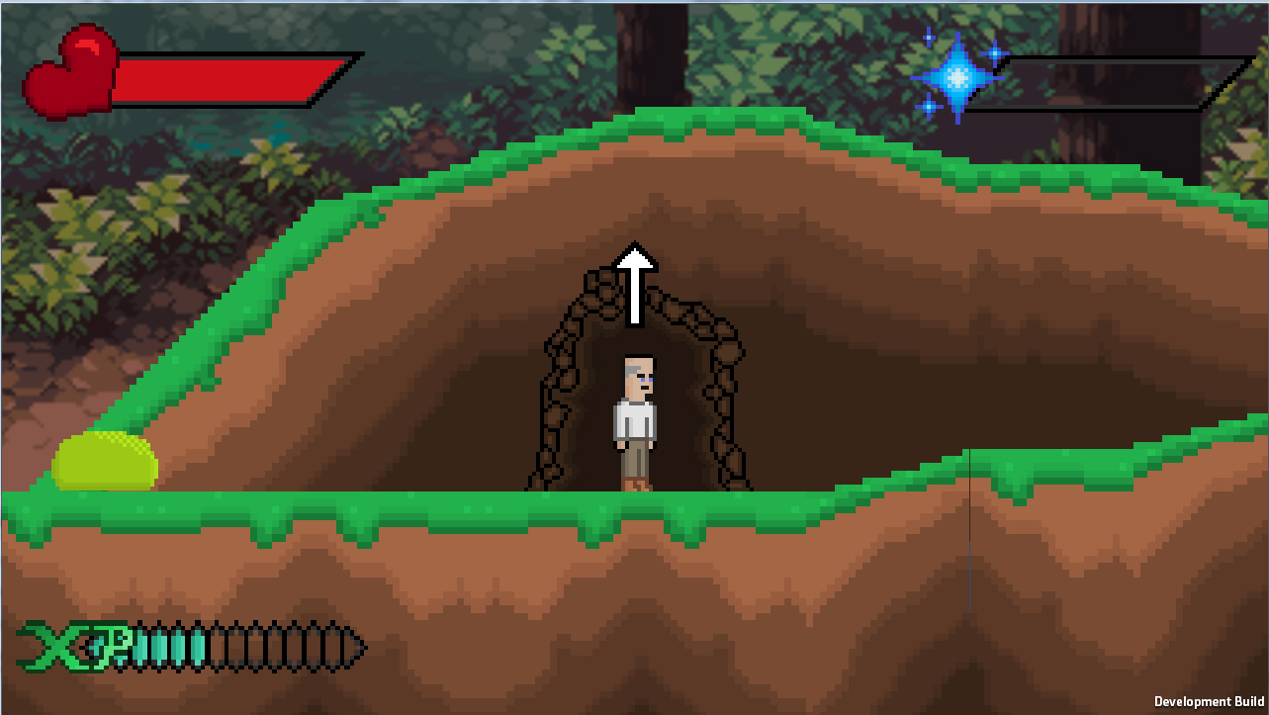

Health bar: This shows how healthy the player is. Stronger enemies will drain more health. Health can be restored by drinking Potions.

Mana bar: This shows the Mana of the player. Mana is used for spells. How much Mana is drained depends on the spell. Mana can be restored by drinking a potion.

XP bar: The XP bar shows how much Experience the player has gained. XP can be earned by slaying monsters and completing Quests. How much XP are earned depends on the strength of the monster or difficulty of the Quest. Every time this bar is full a new level is gained, which makes the player stronger. If no XP are gained the Experience bar won’t be shown.

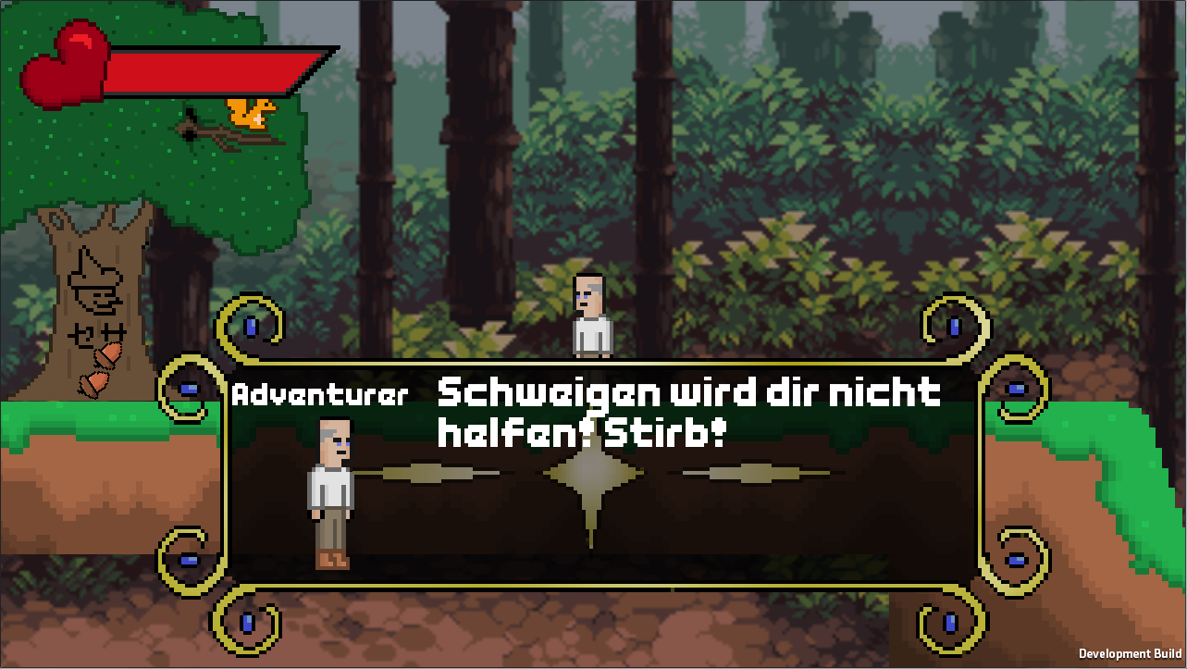

Text field: The Text field appears, when someone is talking. It shows the name of the one who is speaking and a picture of him or her. It also shows the text of the conversation.

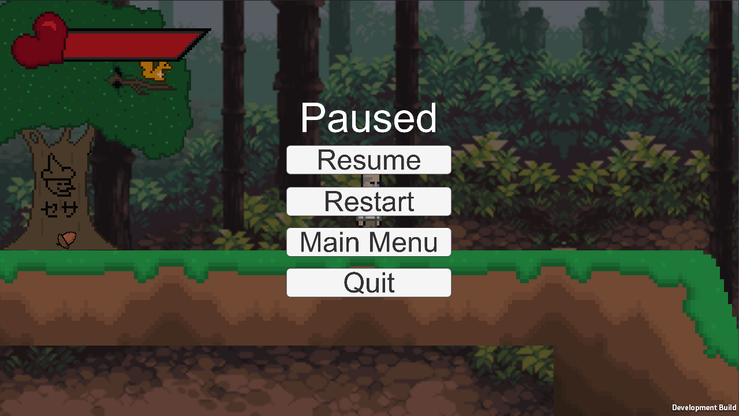

Pause Menu: This is the Pause menu, which pauses the game. This screen can be shown, if the player presses Esc. In this Menu the player can resume, restart, go to the Main Menu or Quit the Game.

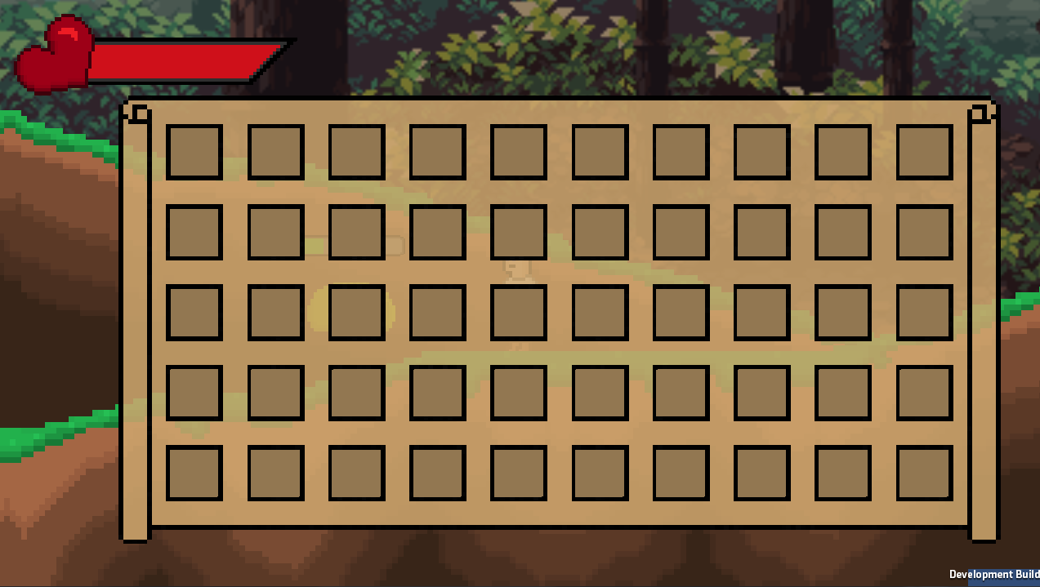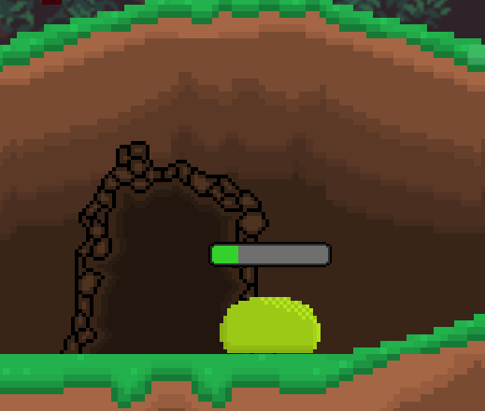

Inventory: This is the Inventory of the player. It can be shown by pressing TAB. The Inventory contains the items, the player has with him.

Slot: One Slot can contain one Item type. For example: one specific Sword, one specific piece of armor, or several pieces of healing potions.

This is the health of the enemy, it is shown, when the player firstly hits the enemy. It drains with every hit the player makes.

## 2.3 Open Points

* **Minigames?**

We haven’t decided yet if we want to implement some Minigames to mix the gameplay up a little bit. There also has to be decided which Minigames we want to implement, how they will look like and how they will play.

* **Difficulty?**

It isn’t entirely clear how difficult the game will be. It mainly focuses to be entertaining for everyone so a good balanced difficult is important.

* **Self-made Soundtrack or open source Soundtrack?**

We don’t know yet if we will include our own soundtracks or if we use some open source ones from the internet.

# 3. Non-functional Requirements

* USE:
  + easy to understand controls
  + game should be playable in German and in English
  + not too complex story
  + clear and uncomplicated dialogues
* EFFIC:
  + fast runtime for smooth gameplay
  + short loading times
  + low memory usage through use of pixel art
* MAINT:
  + maybe there will be a Wii U version later on
  + also we’ll possibly be making one or more DLC’s
  + future release on Steam
* SEC:
  + encryption for the data in the save files
  + source code won’t be included in the user version
  + source code could be offered separately for modders for example
* LEGAL:
  + age requirement will eventually be defined by the uploading site itself
  + other than that there are no law requirements

# 4. Quantity Structure

The one of the most important steps on our project is, to guarantee a smooth run of the game and the low use of memory. In the following tests one will get a brief overview of the game architecture and the specs it needs. Since this is a simple game it won’t need any databases and the saves will be saved into a .txt file and will be reading at any loading process. Also the configurable settings of the game will be saved into a .txt file and can be changed at any time.

# 5. System Architecture and Interfaces

This game is made with Unity 5.3 and usual for indie/pixel games it doesn’t need any high end PC to run this game smoothly.

The game can be played smoothly on every PC that does not have a lesser Windows version of Windows Vista. It can also run on many MacOS Systems or Linux Systems.

Here are the specs:

|  |  |
| --- | --- |
| OS | Windows XP and above, any IOS System which supports Unity, any Linux System which supports Unity |
| CPU | Any CPU which can run Unity 5.3 or above |
| RAM | 1 GB Ram |
| Graphic card | Any Graphic Card which can run Unity 5.3 or above |
| DirectX | DirectX 9 or above |
| Sound | DirectX compatible Soundcards |

# 

# 6. Acceptance Criteria

One of the main selling points of our game is the unique humour.

**Level 0 (Tutorial):**

* graphics for “Stoney”, landscape
* functioning controls
* working container
* squirrel who “throws” acorns

**Level 1 (Beginning):**

* Landscape finished
* Conversation and Backstory for Adventurer finished
* Witch (old Lady) finished
* First few scenes finished before the encounter with the witch
* Pig as ridable mount
* Pig potion, tea, “groceries” and gold magnet finished.
* Gold Magnet Animation for player

**Level 2 (the city):**

* Guards finished
* NPC’s who live in the city finished
* City gate along with some houses finished
* Item shops, inn and alchemist along with the mechanics finished
* Working “White Board” with some Quests
* After some Quests working “Dully Cully” and “Deafy Greefy” Quest

**Level 3 (Slay the dragon and betray the king):**

* Working “Lavania”-District (District where the rich people live and where the player can only pass, when he has a Quest from a rich person or the king. After a while this district will also be passable if the adventurer is famous enough)
* King + Castel(outside) and Audience room finished
* Dialogue between King and Adventurer finished
* Dragon with attack movement finished
* “Dully Cully” and “Deafy Greefy” finished along with some family members
* Items which are given to the adventurer by “Dully Cully” and “Deafy Greefy” working
* Working Dragon Fight + End of Dragon fight Cut scene
* Level where the player travels to the dragon filled with enemies, items and maybe some dungeons and quests.
* End Cut scene for the fight against the dragon
* Cut Scene when the player returns to the king.